Persuasive Design: Motivation
Companion to the video: Script and Illustrations

In Persuasive Design, your users need both ability and motivation to change their behavior. If they have the ability, how do you build motivation?
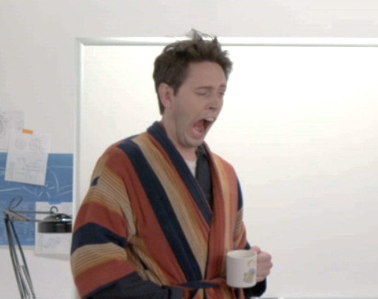
There are tons of different ways.
First, Rewards or Punishments.
This is simple behavioral psychology:
Reward the behavior you want to encourage.

A fitness tracker that congratulates your user for biking today, makes it more likely they’ll bike tomorrow.
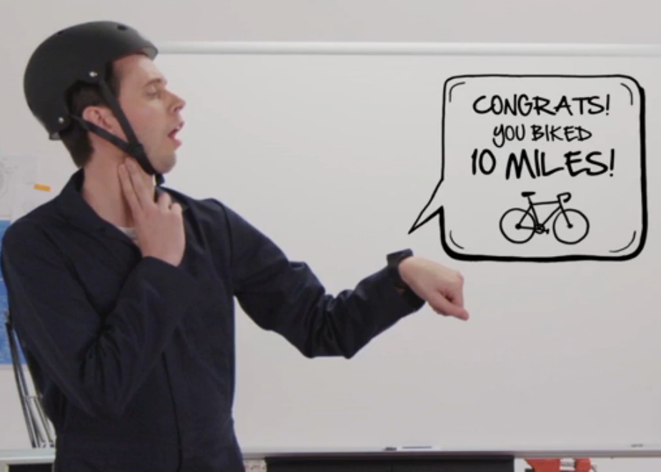

Persuasive Design: Motivation
Companion to the video: Script and Illustrations

And punish the behavior you want to discourage.
Like a car that beeps at your user for leaving the lights on.
Sophisticated versions of these can “Gamify” your user experience, triggering users to higher levels of green behavior.
This can be great for turning short-term actions into long-term goals.

Nagging is another motivator.
For example, a car’s “Check engine” light keeps reminding users until they deal with it.
Unlike punishment, it’s a gentle but persistent request for your user to do something they haven’t done yet.
However, nagging can get annoying, so don’t overuse it.

Then, there’s the user’s feelings toward the product itself. Can you design in an emotional connection?

Persuasive Design: Motivation
Companion to the video: Script and Illustrations

Making your product attractive or likeable motivates people to use it.
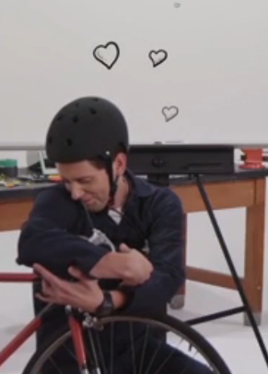
Lots of motivation strategies leverage other people.
Even without your users directly interacting with each other, you can motivate them by Modeling Behavior.
Showing someone else behaving a certain way can inspire your user to do the same thing. Especially when the other person is someone that your user aspires to be, or likes, or is attracted to.
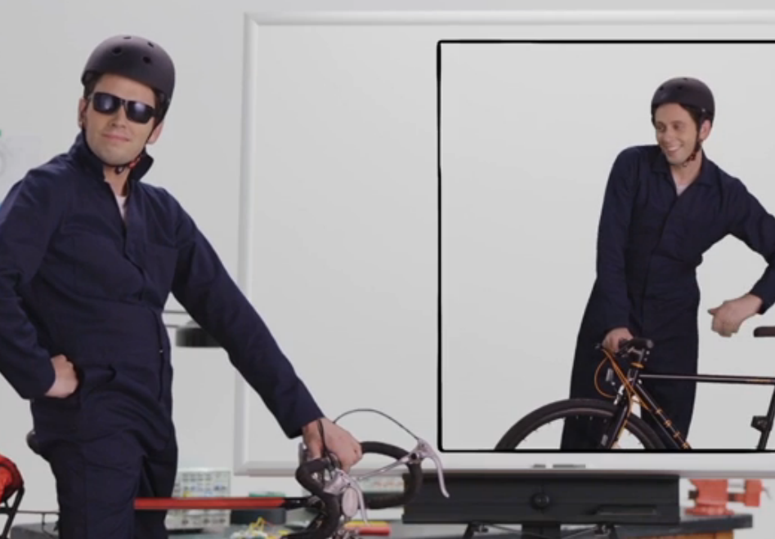

Persuasive Design: Motivation
Companion to the video: Script and Illustrations

For example, on Instructables.com, many people have shown how they’ve modified their bikes to carry cargo so they don’t need a car.
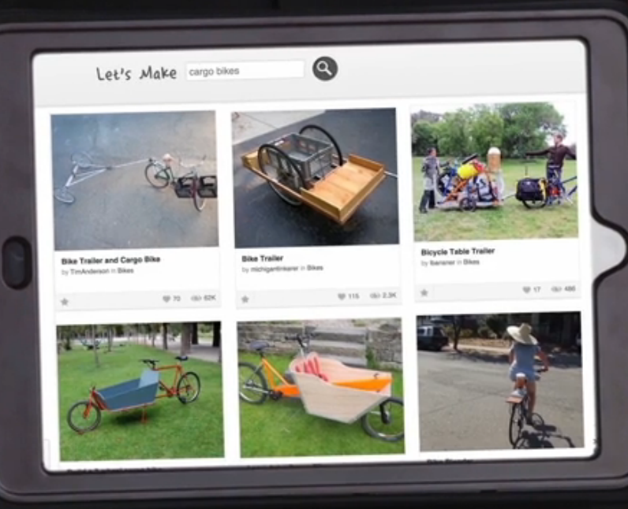

Conversely, pride is motivating. Being green should look good.
When sexy electric sports cars appeared, even people who didn’t care that much about sustainability started switching to electric.
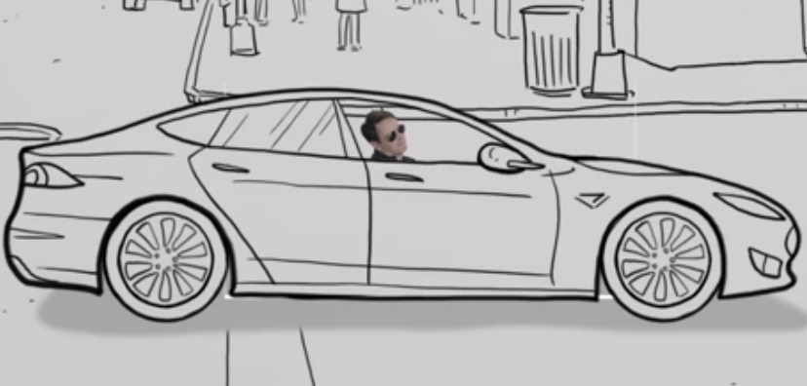

One of the strongest motivators is Social Interaction.
Letting your users share behavior with others builds confidence, comfort, and competence.

Persuasive Design: Motivation
Companion to the video: Script and Illustrations

This can be through cooperation, like your fitness tracker helping you find other bicyclists to ride with,
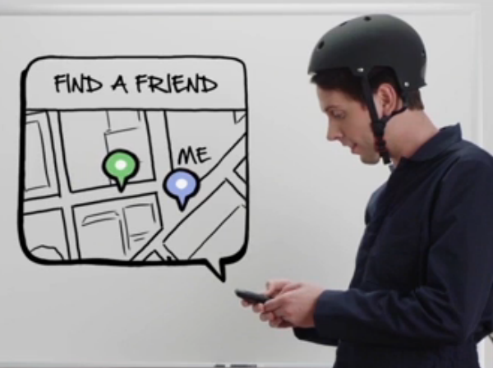

...or it can be through competition, like showing who wins the prize for riding the most.
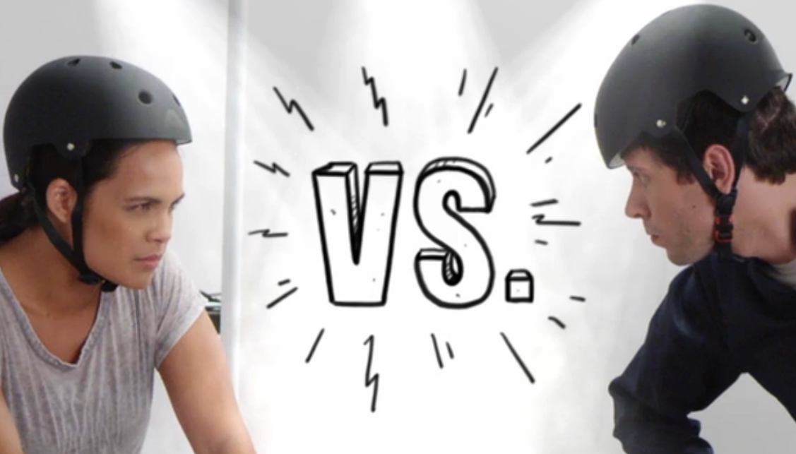

These and many other strategies can motivate your users.
But remember, your users need both motivation and ability to actually change their behavior.
Persuasive design can lead people to more sustainable lifestyles in ways impossible through engineering, just as green engineering can accomplish things impossible to fix through behavior.
Smart design uses both together, for the greatest improvement possible.
Autodesk is a registered trademark of Autodesk, Inc., and/or its subsidiaries and/or affiliates in the USA and/or other countries. All other brand names, product names, or trademarks belong to their respective holders. Autodesk reserves the right to alter product and services offerings, and specifications and pricing at any time without notice, and is not responsible for typographical or graphical errors that may appear in this document. © 2011 Autodesk, Inc. All rights reserved.

