Persuasive Design: Ability
Companion to the video: Script and Illustrations

In Persuasive Design, there are many ways to change a user’s behavior as they interact with your product or service.
Many users are already motivated to make sustainable decisions, but there may be things getting in their way.
How can you give users more ability to do their desired behaviors?
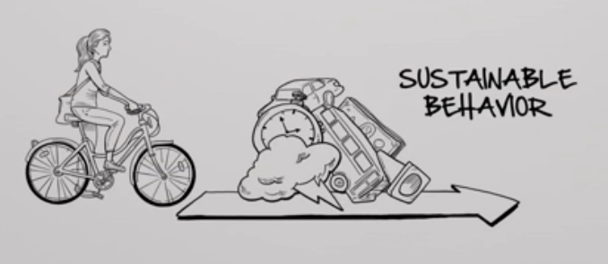

There are lots of ways.
One of the strongest is to make things easier or more convenient.
Removing barriers to sustainable behavior.

For example, if you’re trying to help your users reduce their environmental impacts from transportation, make it easier to use transit and bicycles instead of cars.

Persuasive Design: Ability
Companion to the video: Script and Illustrations

Like separating bike lanes from car traffic, and providing ways for bikes to get on transit.
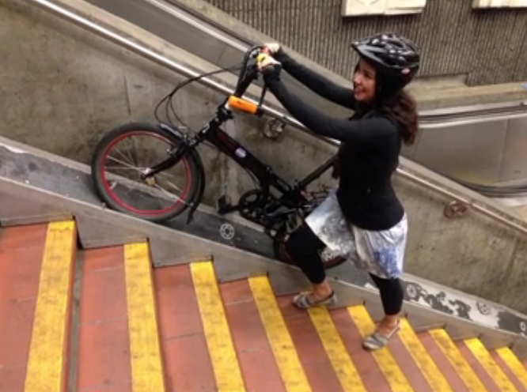
Likewise, you can make unsustainable behaviors less convenient--like having less parking for cars, or making it more expensive.
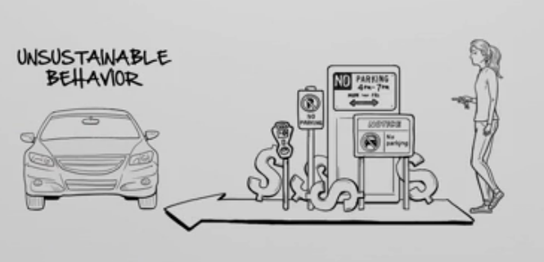
But don’t overdo it, or people won’t use your product.

Another way to increase ability is setting defaults.
Most people don’t bother to change the factory settings on a product, so why not make the most sustainable settings the default?

Persuasive Design: Ability
Companion to the video: Script and Illustrations

Like a hybrid car defaulting to a low-power high-efficiency mode.
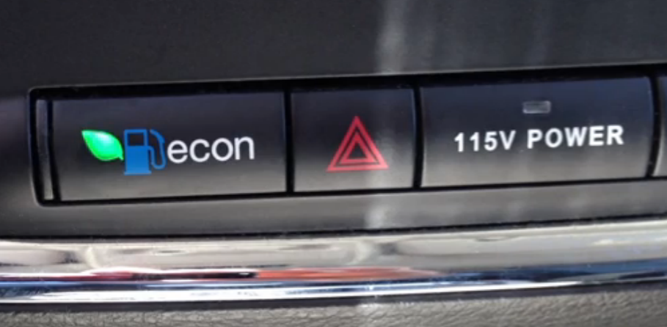

Another tool is leading the user through the behavior when the process is complicated or has multiple steps.
Persuasive design can be super powerful on mobile devices, because they’re always with the user.
So, a mapping app that shows public transit options and gives you turn-by-turn directions in real-time is a great way to trigger more sustainable behavior.
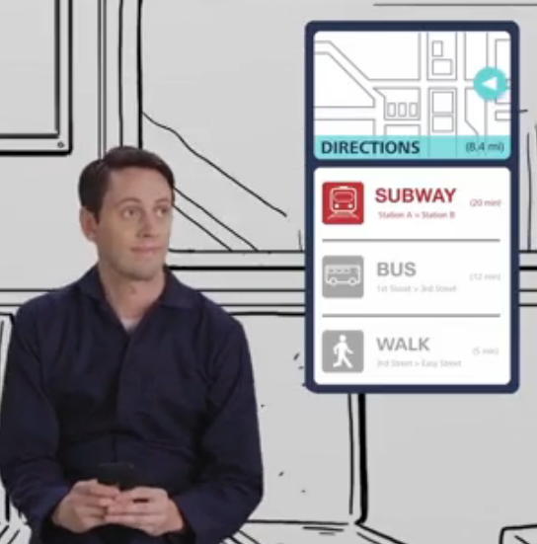

Persuasive Design: Ability
Companion to the video: Script and Illustrations

Another way to increase ability is to calculate, simulate, or measure in order to give the user information that is specific and actionable.
For example: A public transit app can not only tell users where to go...
but it can calculate how long it'll take and how much it'll cost.
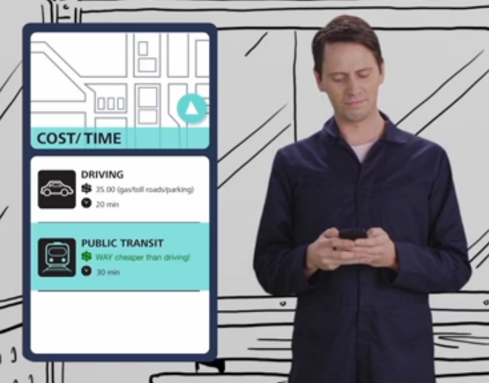
This allows the user to make the most informed decision possible.

Finally, a powerful persuasive tool is giving users feedback in real-time on how the product is performing.
Rather than keep a product’s environmental impacts hidden away, being transparent gives your users some control over their impact.
Like a car that shows gas mileage change in real-time. This allows users to see the impact of inefficient decisions - like driving faster than necessary.
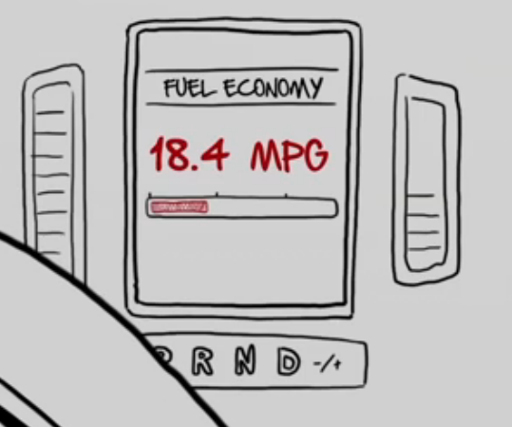

Persuasive Design: Ability
Companion to the video: Script and Illustrations

Increasing your user’s ability is often the most powerful persuader, because motivation can be an uphill battle.
But ability is just one piece of the puzzle.
Next, let’s look at how designers can increase motivation.

Autodesk is a registered trademark of Autodesk, Inc., and/or its subsidiaries and/or affiliates in the USA and/or other countries. All other brand names, product names, or trademarks belong to their respective holders. Autodesk reserves the right to alter product and services offerings, and specifications and pricing at any time without notice, and is not responsible for typographical or graphical errors that may appear in this document. © 2011 Autodesk, Inc. All rights reserved.

