Introduction to Persuasive Design
Companion to the video: Script and Illustrations

When it comes to designing products, we’ve talked a lot about Green Engineering, which makes a product more sustainable, with no action needed from the user.
Things like a more efficient power supply, or greener materials.
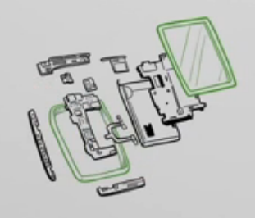
Your user’s experience with that product doesn’t change.

Green Behavior
But what if you could change your user’s lifestyle with Green Behavior?
Both this and Green Engineering are vital for creating a sustainable future. For now, let’s focus on Green Behavior. Specifically, how we can reduce environmental impacts from personal transportation.

If your product persuades its users to behave more sustainably, you’ve made a greener product.

Here’s one example: Say you’re designing mapping software for a mobile phone.
If your interface automatically presents biking and public transportation options, along with driving instructions, you’re enabling greener user behavior.

Introduction to Persuasive Design
Companion to the video: Script and Illustrations

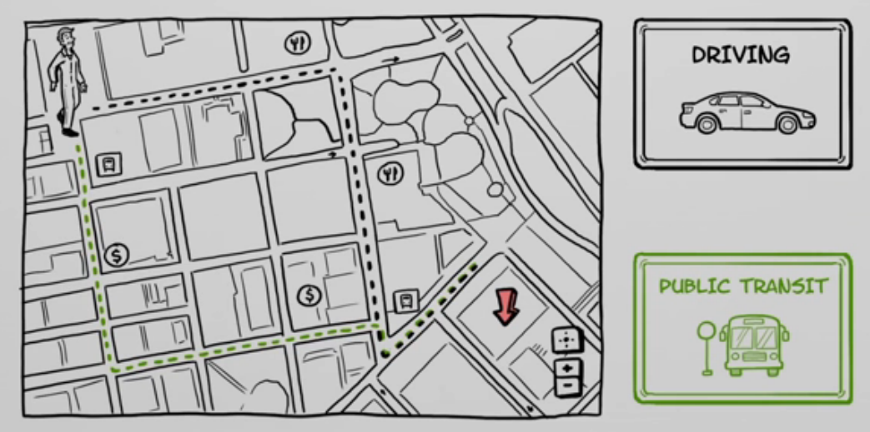
Even without redesigning the bus or the bike, you’ve made them more viable compared to driving.
This is called Persuasive Design, and it can be used to varying degrees in products.

In the mapping app, persuasive design is only a small part of the product, but lots of people use it.
You can also make a product that only a specific target audience uses, but it exists entirely to change their behavior.
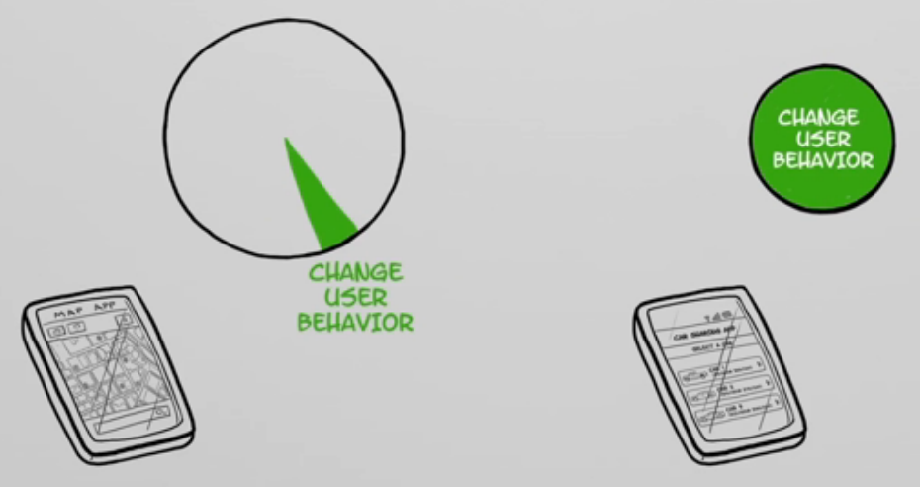

Introduction to Persuasive Design
Companion to the video: Script and Illustrations

For example, a car-sharing app allows users to get rid of their own car, by letting them rent a car on demand.
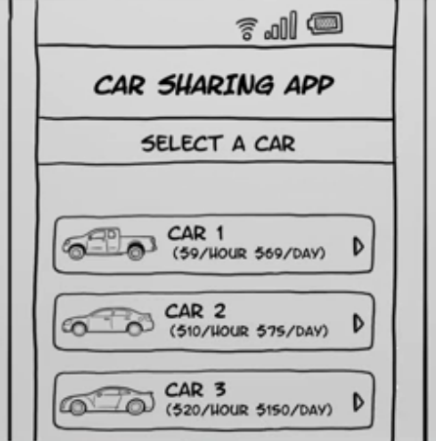
Both of these techniques can nudge people’s behavior in both the short-term and the long-term.

There’s power in persuasion. As designers, it’s our opportunity to harness that power for good. Which includes avoiding unintended consequences of persuasion.
For example, with the car-sharing app: if it persuades users to drive all the time, it actually increases their environmental impact.
But to be clear, persuasive design isn’t marketing. It’s changing user behavior through their interaction with your product.
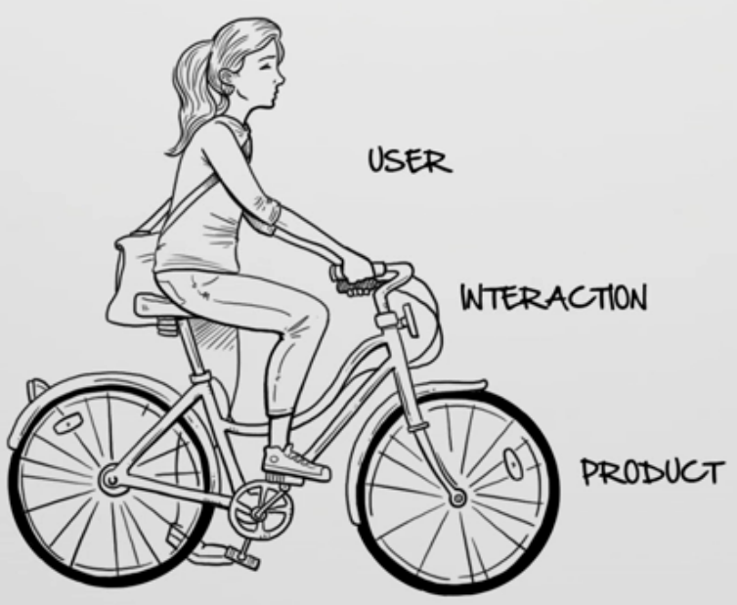

Introduction to Persuasive Design
Companion to the video: Script and Illustrations

This can be for product designers, interaction designers, or user experience designers making services.

The most effective strategies trigger users who are both motivated and able to do the behavior.
According to researcher BJ Fogg, persuasive design can increase both people’s ability and motivation. When both are high, you can trigger the target behavior.
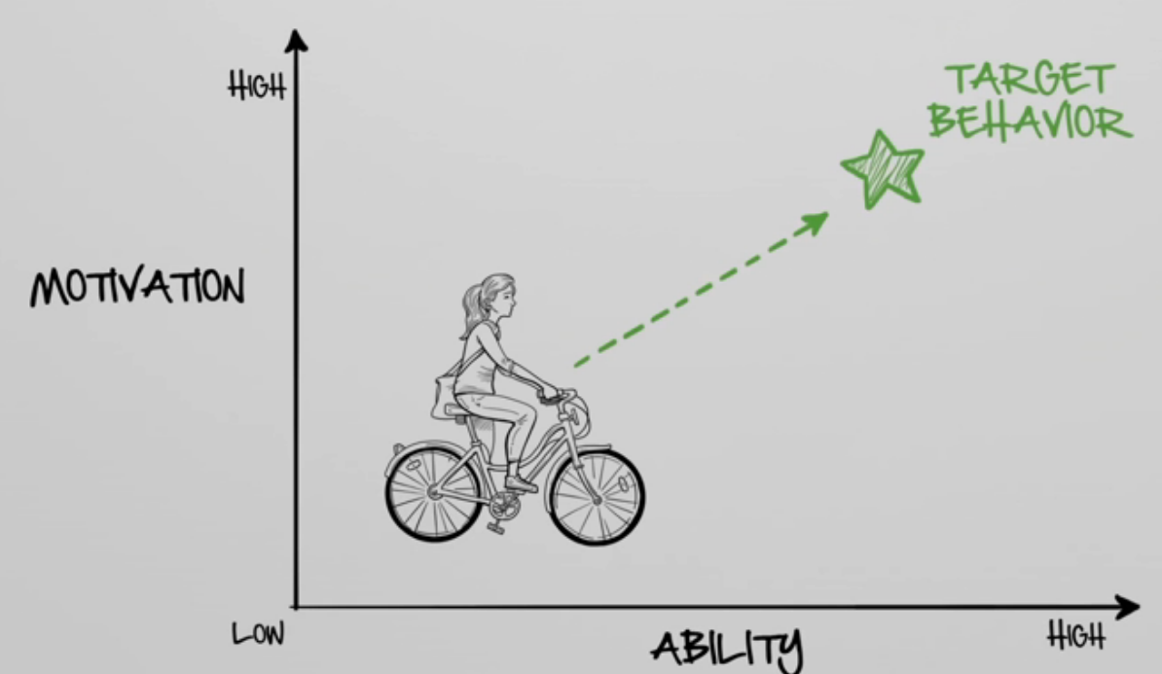

We’ll explore these strategies in the coming videos, and how they can help your users live more sustainable lives.

Autodesk is a registered trademark of Autodesk, Inc., and/or its subsidiaries and/or affiliates in the USA and/or other countries. All other brand names, product names, or trademarks belong to their respective holders. Autodesk reserves the right to alter product and services offerings, and specifications and pricing at any time without notice, and is not responsible for typographical or graphical errors that may appear in this document. © 2011 Autodesk, Inc. All rights reserved.

